Minimum ISIS NeXus file format
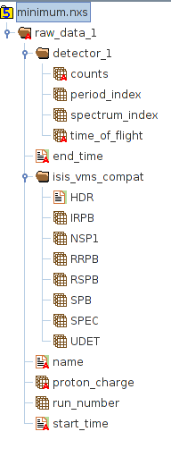
- The top-level group must be called 'raw_data_1' and have a string attribute 'NX_class' with value 'NXentry'
- Group 'raw_data_1' must have:
- Group 'isis_vms_compat'.
- Group 'detector_1'.
- Data sets:
Name | Type | Value
name | String | Instrument name
proton_charge | Float 32 | Proton charge
run_number | Int 32 | Run number
start_time | String[19] | Start time yyyy-mm-ddThh:mm:ss
end_time | String[19] | End time yyyy-mm-ddThh:mm:ss
- Group isis_vms_compat ' must have:
Name | Type | Value
HDR | String[80] | Header
IRPB | Int 32 [32] | Array of 32-bit integers. Used fields:  IRPB[0]: actual run duration  IRPB[1]: scaler for above (1=seconds)  IRPB[2]: test interval for above (seconds)  IRPB[3]: dump interval  IRPB[4]: scaler for above  IRPB[5]: interval for above  IRPB[6]: 2**k where source frequency = 50 / 2**k

(‘isis_vms_compat’ continued)
Name | Type | Value
RRPB | Float 32 [32] | Array of 32 bit floats. Used fields:  RRPB[7]: good proton charge (uA.hour)  RRPB[8]: total proton charge (uA.hour)  RRPB[9]: good frames  RRPB[10]: raw frames  RRPB[11]: requested run duration (units as for "duration" above)  RRPB[12]: actual run duration in seconds  RRPB[13]: monitor sum 1  RRPB[14]: monitor sum 2  RRPB[15]: monitor sum 3
SPB | Int 32 [32] | Array og 32 bit integers. Used fields:  SPB[2]: sample geometry flag
RSPB | Float 32 [32] | Array of 32 bit floats. Used fields:  RSPB[3]: sample thickness  RSPB[4]: sample height  RSPB[5]: sample width
NSP1 | Int 32 | Number of spectra
SPEC | Int 32 [NSP1] | Spectra indices
UDET | Int 32 [NSP1] | Detector IDs
- Group ‘detector_1’ must have:
Name | Type | Value
counts | Int 32  [np ×ns ×nb] | 3D array if 32 bit integers.  - np – number of periods  - ns – number of spectra  - nb – number of time bins  Attributes:  - signal (Int 32) = 1  - units (String)  - axes (String) = “period_index, spectrum_index, time_of_flight”
period_index | Int 32 [np] | Period indices
spectrum_index | Int 32 [ns] | Spectrum numbers
time_of_flight | Float 32 [nb+1] | Time of flight bin boundaries

